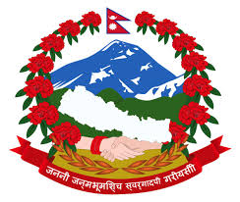
SURVEY CAMP FOR DIPLOMA STUDENTS

Report on A Closed Survey Camp submitted in the fulfillment of the practical for the degree of Diploma in Geomatics Engineering (3rd Year)

By:
Head of Department
Department of Geomatics Engineering

Department of Geomatics Engineering
Nepal Banepa Polytechnic Institute
CTEVT
Banepa, Kavre

Background

Surveying is the science and art of determining the relative positions of above, on, or beneath the surface of earth, and is the most important part of Geomatics Engineering. Cadastral surveying is the sub-field of cadastre and surveying that specializes in the establishment and re-establishment of real property boundaries. It is an important component of the legal creation of properties. A cadastral surveyor must apply both the spatial-measurement principles of general surveying and legal principles such as respect of neighboring titles. A common use of a survey is to determine a legal property boundary.
This survey camp was conducted in order to train students practically and implies their skills on the field rather than on the course book. Making students proficient in handling survey equipment’s like plane table and total station was our primary focus. Furthermore, this survey camp helps students to build confidence to conduct cadastral survey on required accuracy and a motivation to work in team and develop teamwork skills.

Objectives

The main objective of the camp was to provide a basic knowledge of practical implementation of different survey work, which must be encountered in future. It enhances the practical knowledge thereby implementing different work and in other side it involves self-assured feeling everlastingly. It guides to tread on the path ending with success. The sub objectives of the survey camp are as follows:
- To become familiar with the problems that may arise during the fieldworks.
- To became familiar with proper handling of instrument and their functions.
- To become familiar with the spirit and importance of teamwork, as surveying is not a single person work.
- To complete the given project in scheduled time and thus knows the value of time.
- To collect required data in the field in systematic ways.
- To compute and manipulate the observed data in the required accuracy and present it in diagrammatic and tabular form in order to understand by others.
- To tackle the mistake and incomplete data from the field during the office work.
- To make capable for the preparation of final report

Activities

The activities were divided into 3 parts, as outlined below:
- Traversing: For the first two days of the survey camp, students were involved in establishment of horizontal and vertical control point through traversing. Closed loop traverse was performed using Total Station, where 6 control points were established.

- Plane Table cadastral Survey: Students were provided a perma-trace paper and plane table instruments like plane table set, alidade, tape etc. Using the principals of plane table students were given task to prepare a cadastral map on the perma trace paper itself. Scale of 1:500 was chosen for plotting, by which area of 14400 sq meters of area was covered.

- Digital Cadastral Survey: Within the area of about 15000 sq meters, a detailed parcel survey was conducted. Survey was conducted using total station and using the control points established after traversing. A project was created in the “Field genius” software and data’s were extracted to do further plotting in GIS and parcel editor.

S.N. | Day | Planned Task | Actual Task
1 | 19th Mangsir | Arrive Jiri by Evening | Arrived Jiri by Evening
2 | 20th Mangsir | Reconnaissance, monumentation, and establishment of control points for graphical & digital cadastral survey | Reconnaissance, monumentation, and establishment of control points for graphical & digital cadastral survey
3 | 21st Mangsir | Detail graphical cadastral survey by 4 groups & digital cadastral survey by other 4 groups. | Traversing, computation and establishment of control points for graphical & digital cadastral survey
4 | 22nd Mangsir | Detail graphical cadastral survey by 4 groups & digital cadastral survey by other 4 groups. | Detail graphical cadastral survey by 4 groups & digital cadastral survey by other 4 groups.
5 | 23rd Mangsir | Detail graphical cadastral survey by 4 groups & digital cadastral survey by other 4 groups. | Detail graphical cadastral survey by 4 groups & digital cadastral survey by other 4 groups.
6 | 24th Mangsir | Detail graphical cadastral survey by 4 groups & digital cadastral survey by other 4 groups. | Detail graphical cadastral survey by 4 groups & digital cadastral survey by other 4 groups.
7 | 25th Mangsir | Swipe of the work among the groups. Detail graphical cadastral survey by 4 groups & digital cadastral survey by other 4 groups. | Detail graphical cadastral survey by 4 groups & digital cadastral survey by other 4 groups.
8 | 26th Mangsir | Detail graphical cadastral survey by 4 groups & digital cadastral survey by other 4 groups. | Swipe of the work among the groups. Detail graphical cadastral survey by 4 groups & digital cadastral survey by other 4 groups.
9 | 27th Mangsir | Detail graphical cadastral survey by 4 groups & digital cadastral survey by other 4 groups. | Detail graphical cadastral survey by 4 groups & digital cadastral survey by other 4 groups.
10 | 28th Mangsir | Detail graphical cadastral survey by 4 groups & digital cadastral survey by other 4 groups. | Detail graphical cadastral survey by 4 groups & digital cadastral survey by other 4 groups.
11 | 29th Mangsir | Detail graphical cadastral survey by 4 groups & digital cadastral survey by other 4 groups. | Detail graphical cadastral survey by 4 groups & digital cadastral survey by other 4 groups.
12 | 1st Poush | Back to NBPI | Back to NBPI

Deliverable

Two maps (graphical and Digital) were produced by the end of the survey camp. Graphical map was produced on the field itself by plane table survey, and digital map was produced after extracting data from Total Station and then plotting it in GIS software and organizing it by parcel editor tool.
Both maps were produced in the scale of 1:500.

[To attach: Photograph of map]

Annex I - Photographs

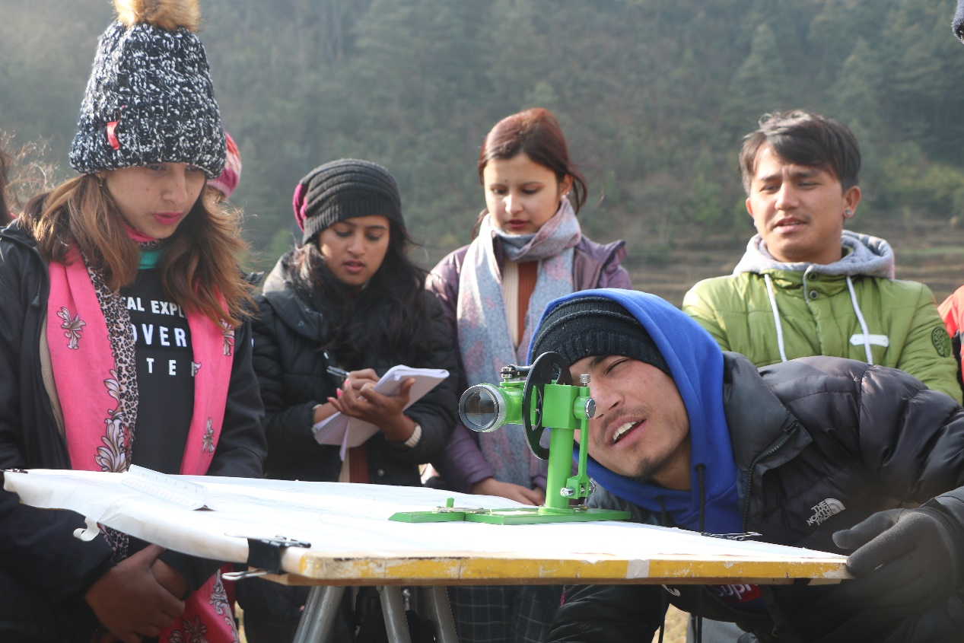
Image 1:Student busy in orientation of Plane Table
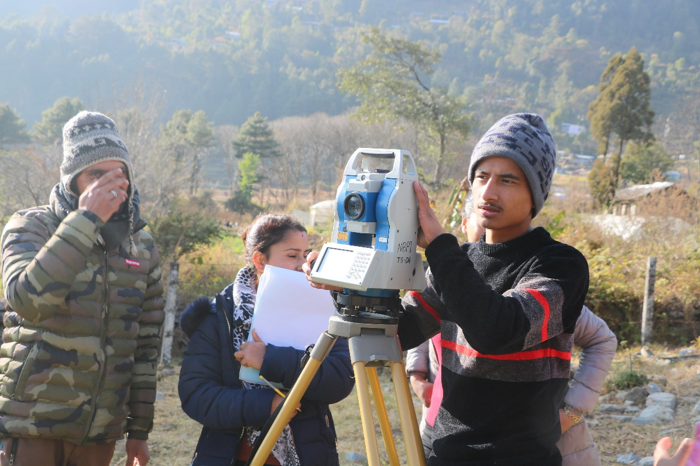
Image 2: Student setting up Total Station
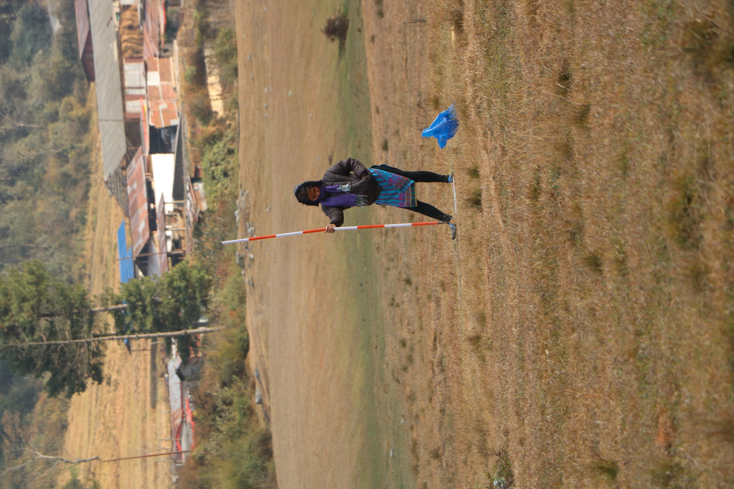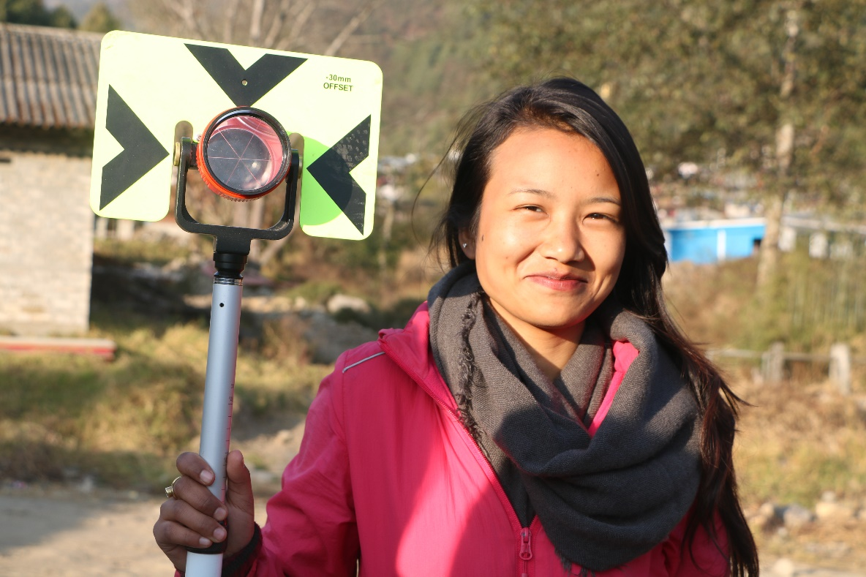
Image 3: Student holding a ranging rod(left) and Prism(right)
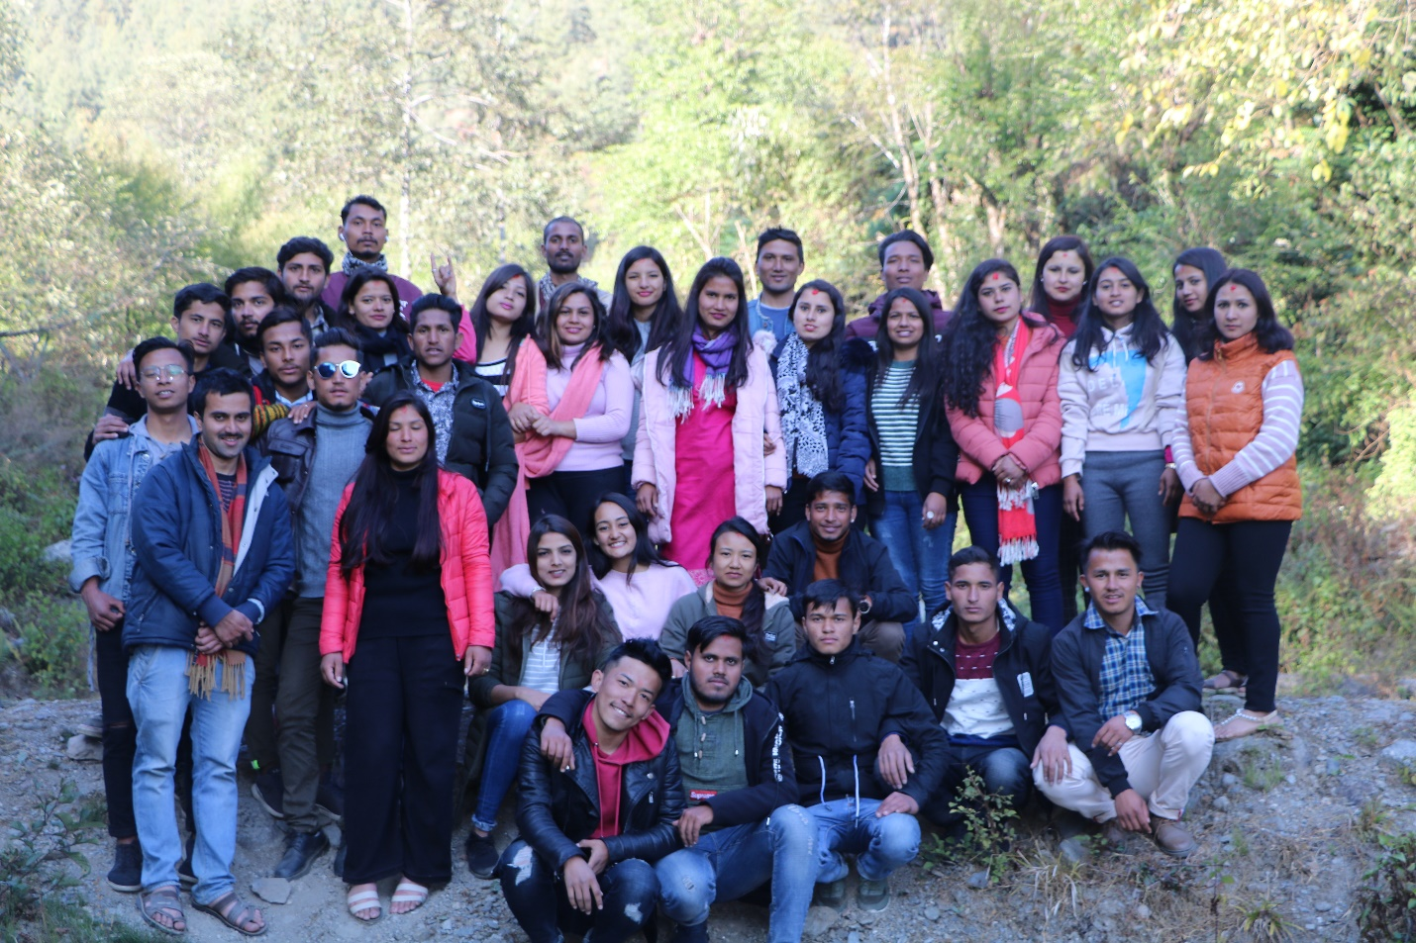
Image 4:Group Photo

